## Screenshots and Validation

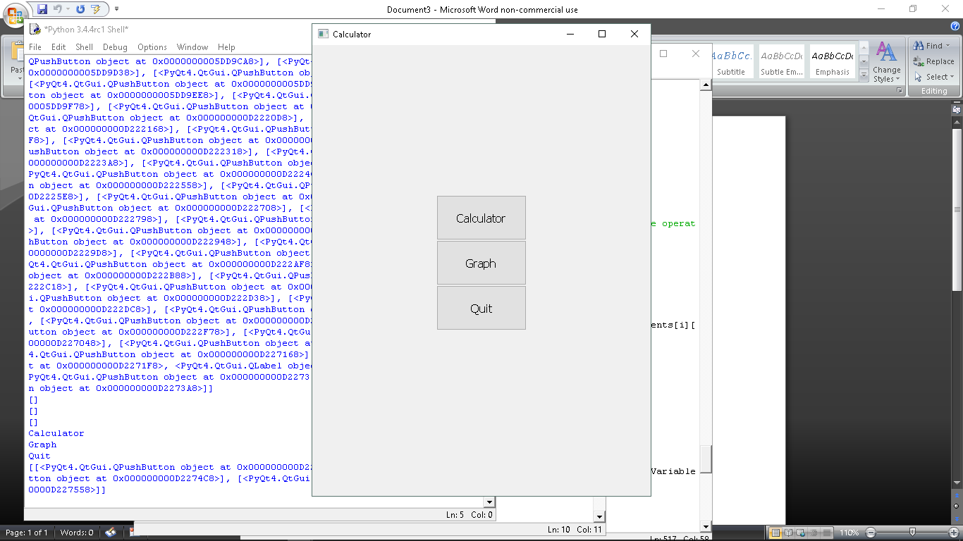

This is the main menu of the program. There are three buttons, ‘Calculator’, ‘Graph’ and ‘Exit’.

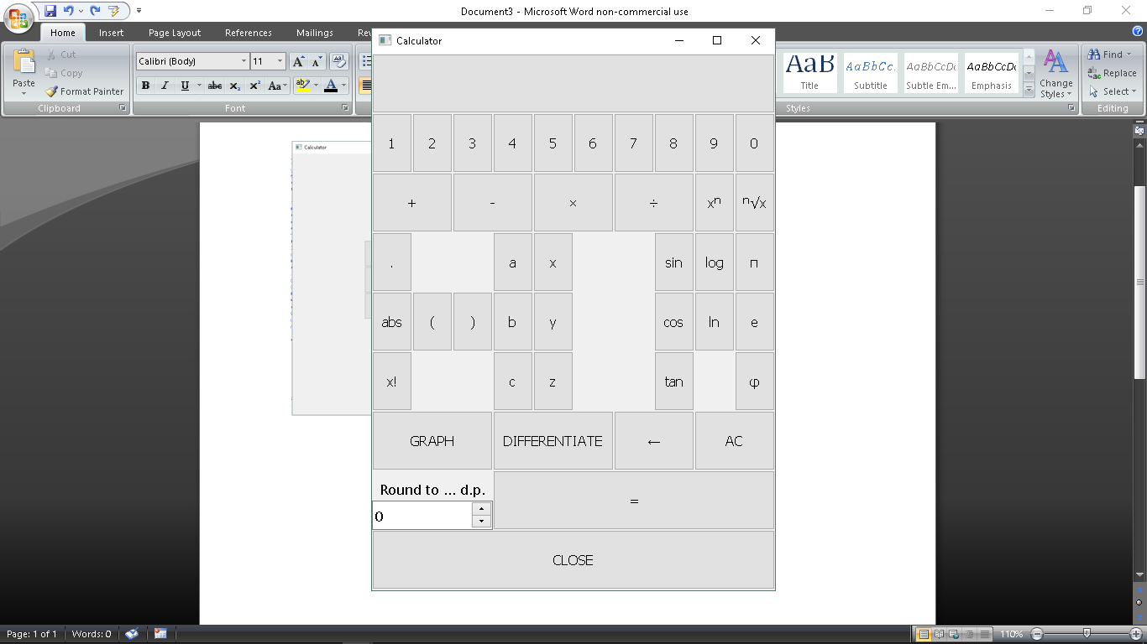

This is the calculator screen.

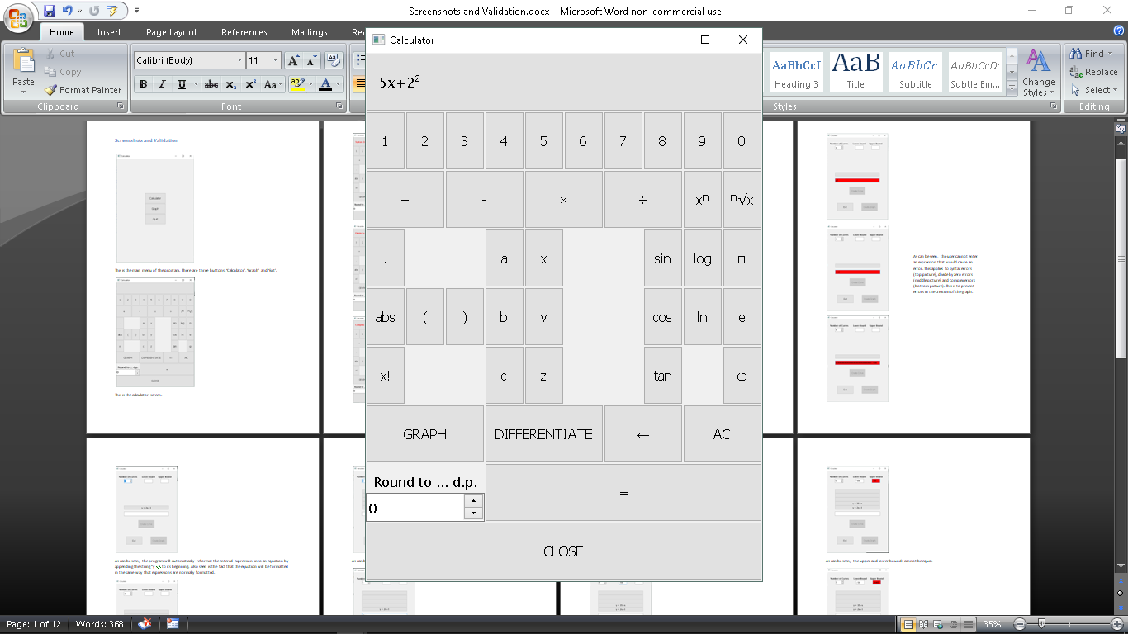

As can be seen, the program will format expressions correctly, writing indices in superscript.

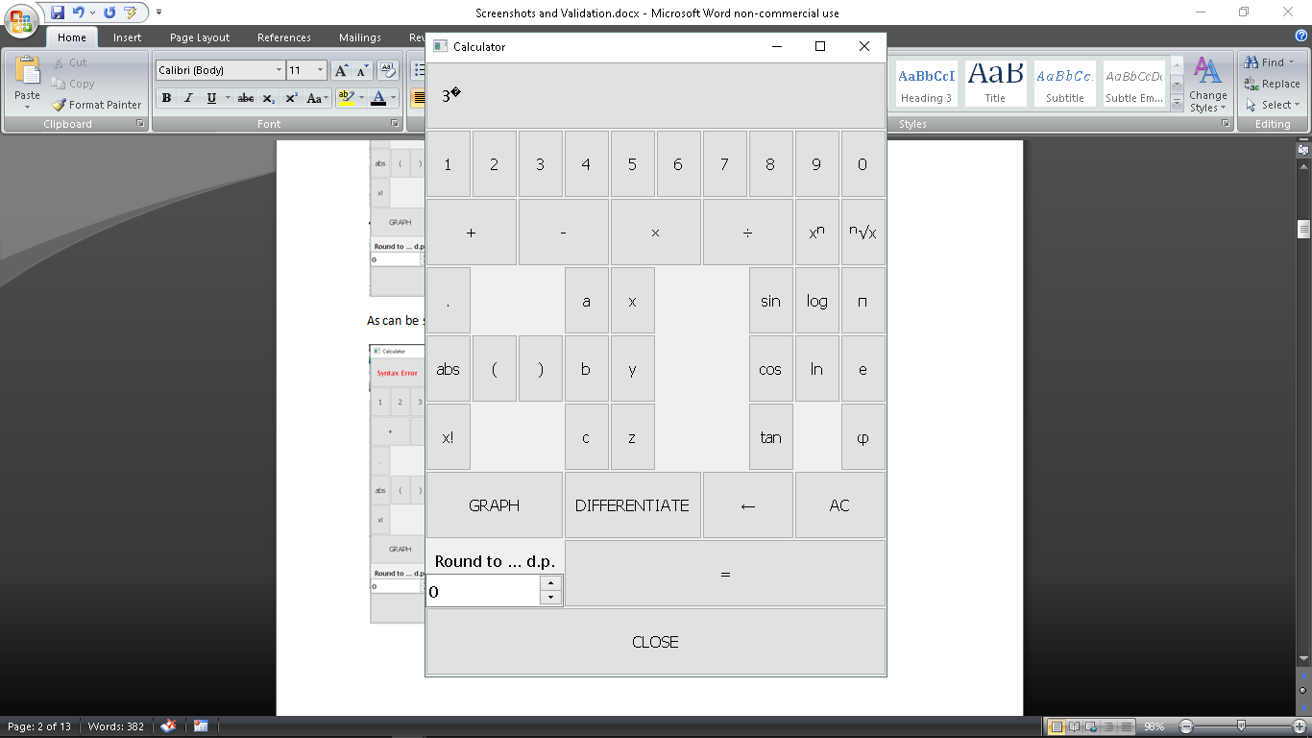

As can be seen, when no indices have been entered, the program will display a replacement character to inform the user they are entering a power.

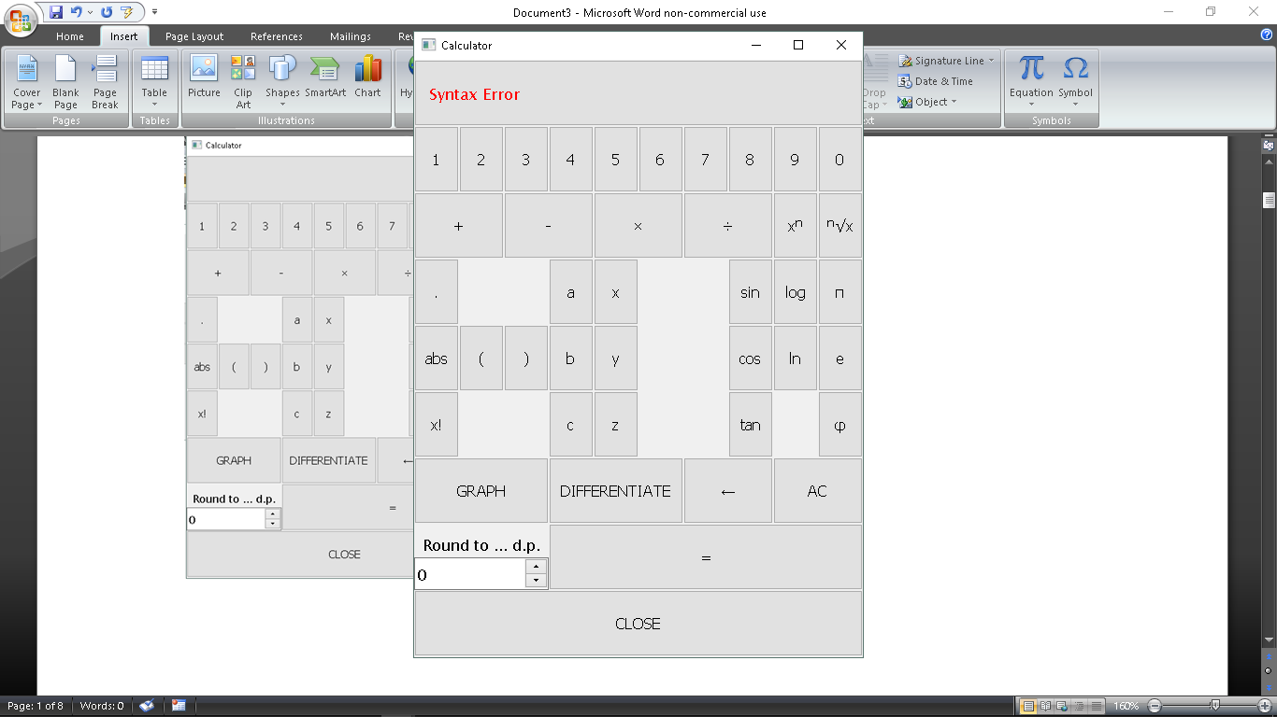

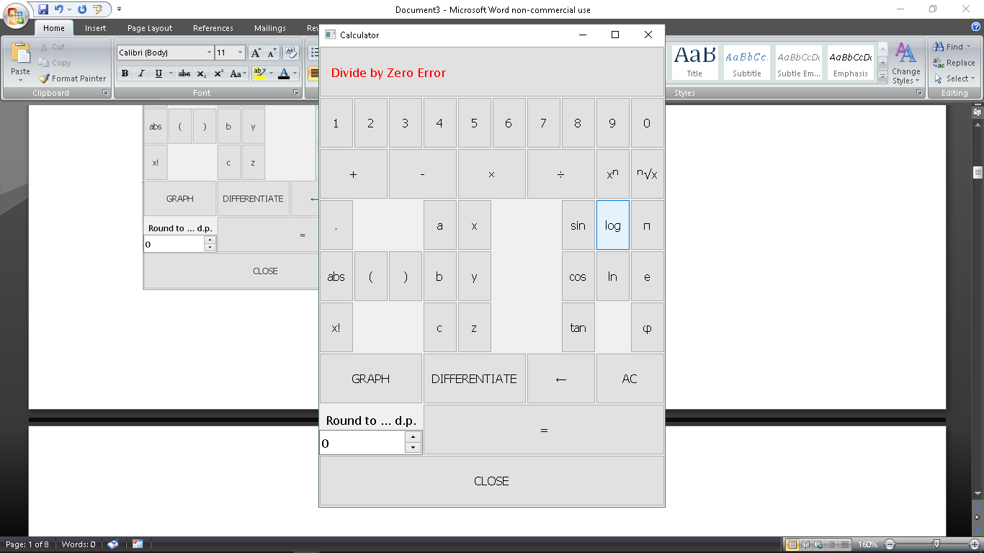

As can be seen, errors in the expression do not crash the program. It instead throws a custom error, which is displayed on the calculator’s display.

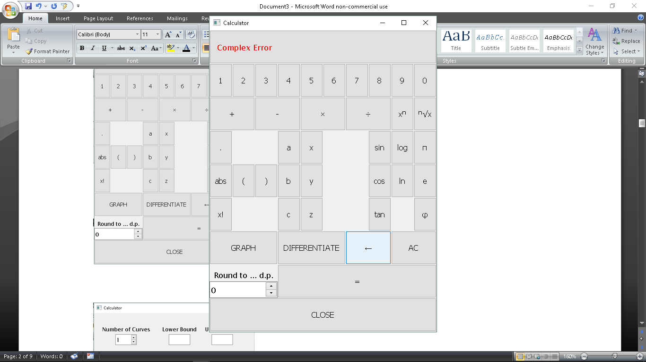

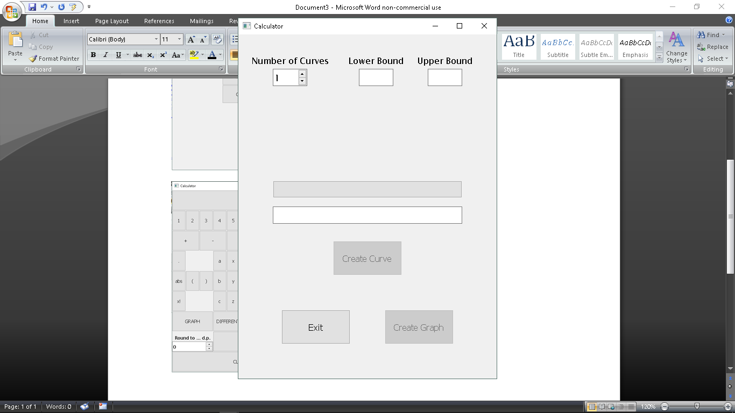

This is the graph creation screen. The spin box containing the maximum number of curves can be seen at the top right. The bounds can be seen to the right of it. The slots can be seen above the long text fill, and will increase in number from the bottom up.

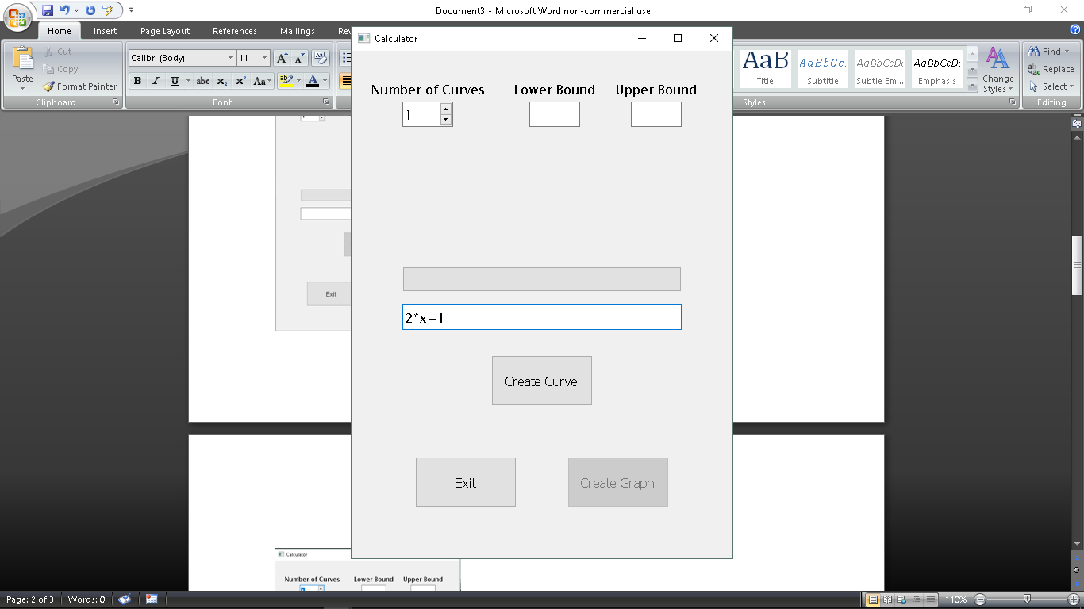

The wide text fill is used to enter the curves’ expressions.

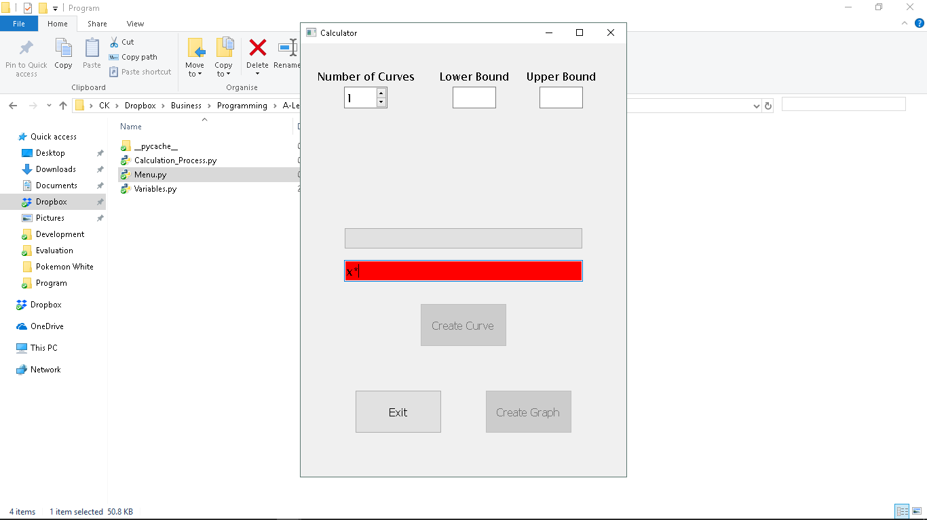

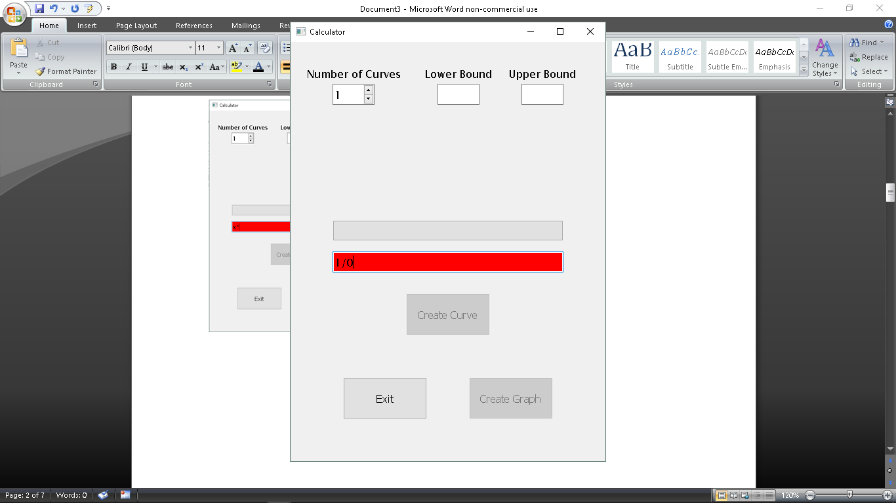

As can be seen, the user cannot enter an expression that would cause an error. This applies to syntax errors (top picture), divide by zero errors (middle picture) and complex errors (bottom picture). This is to prevent errors in the creation of the graph.

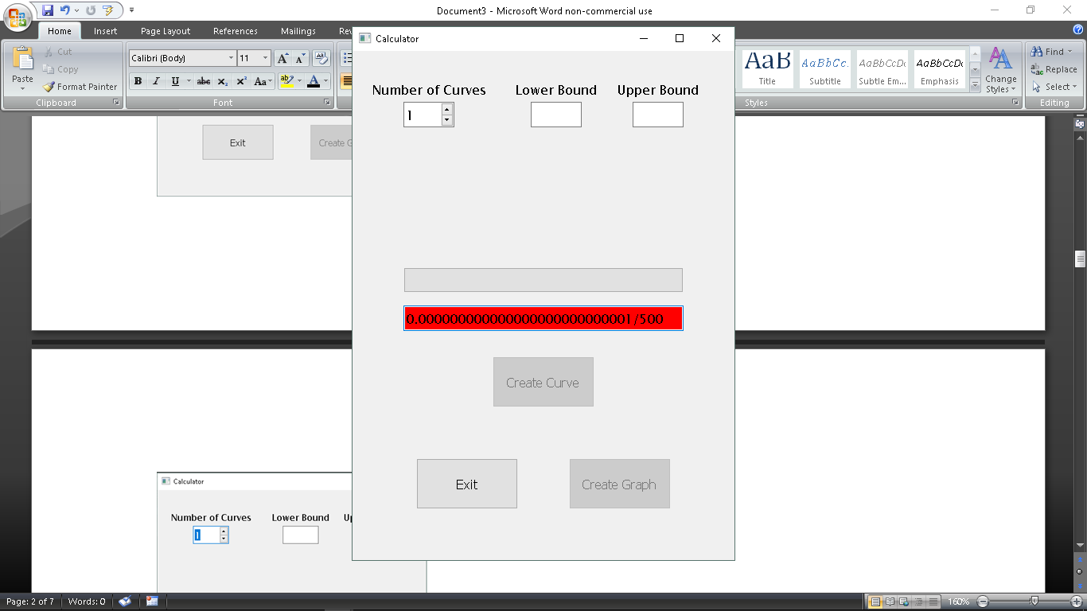

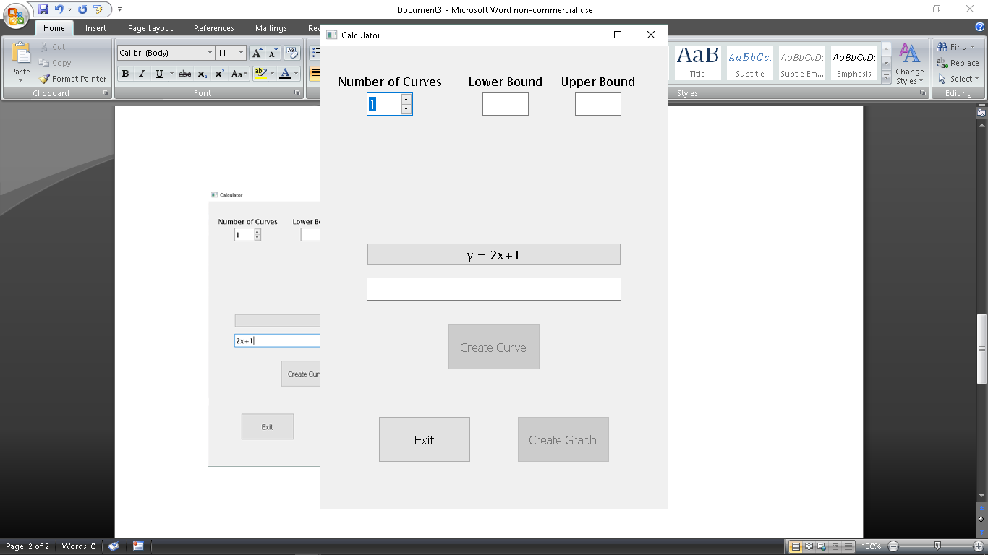

As can be seen, the program will automatically reformat the entered expression into an equation by appending the string “y = ” to its beginning. Also seen is the fact that the equation will be formatted in the same way that expressions are normally formatted.

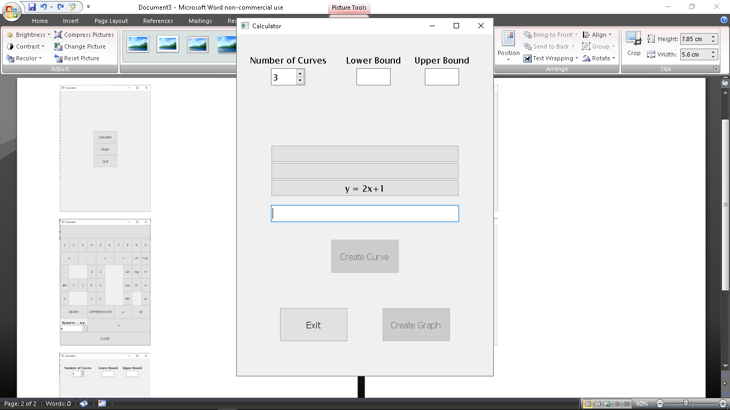

As can be seen, there can be more than one slot.

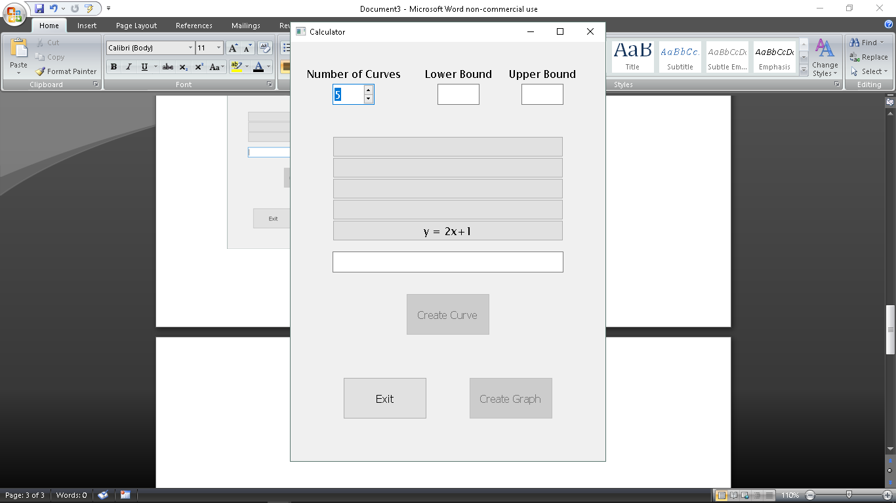

As can be seen, there can be a maximum of five slots.

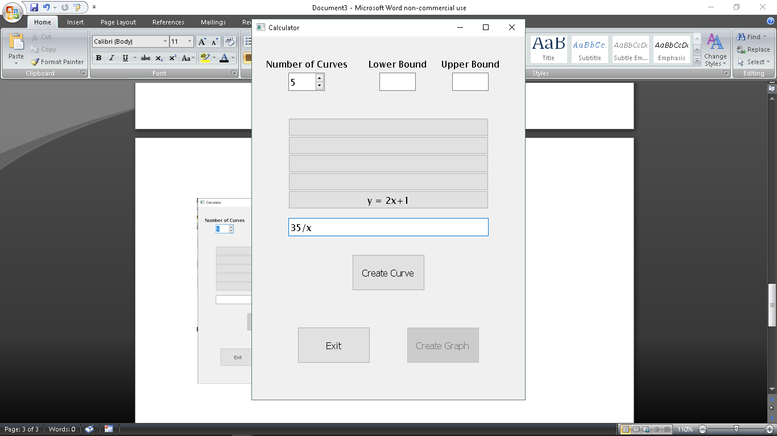

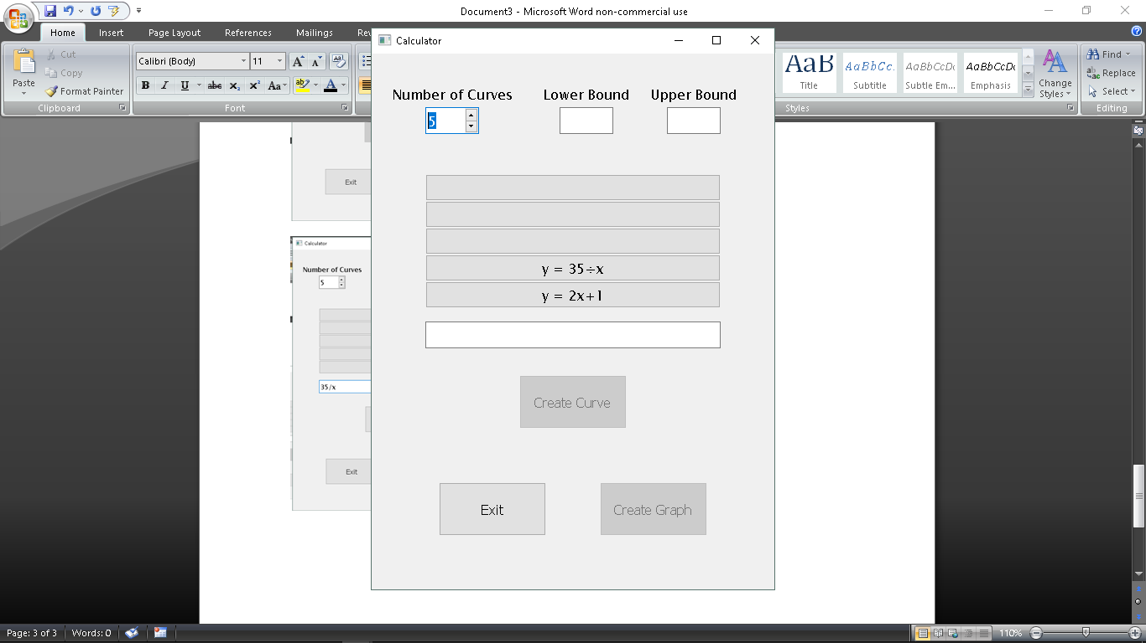

As can be seen, multiple curves can be entered.

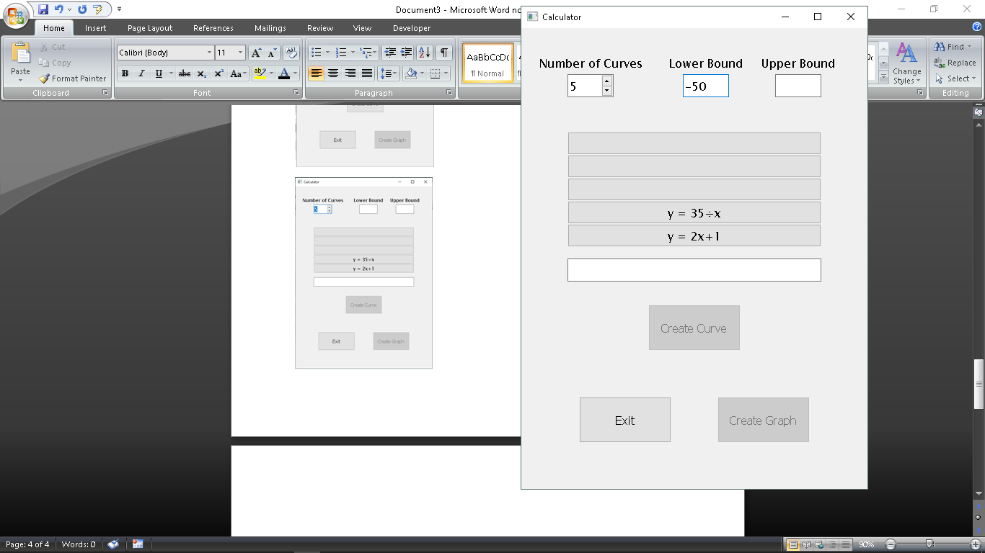

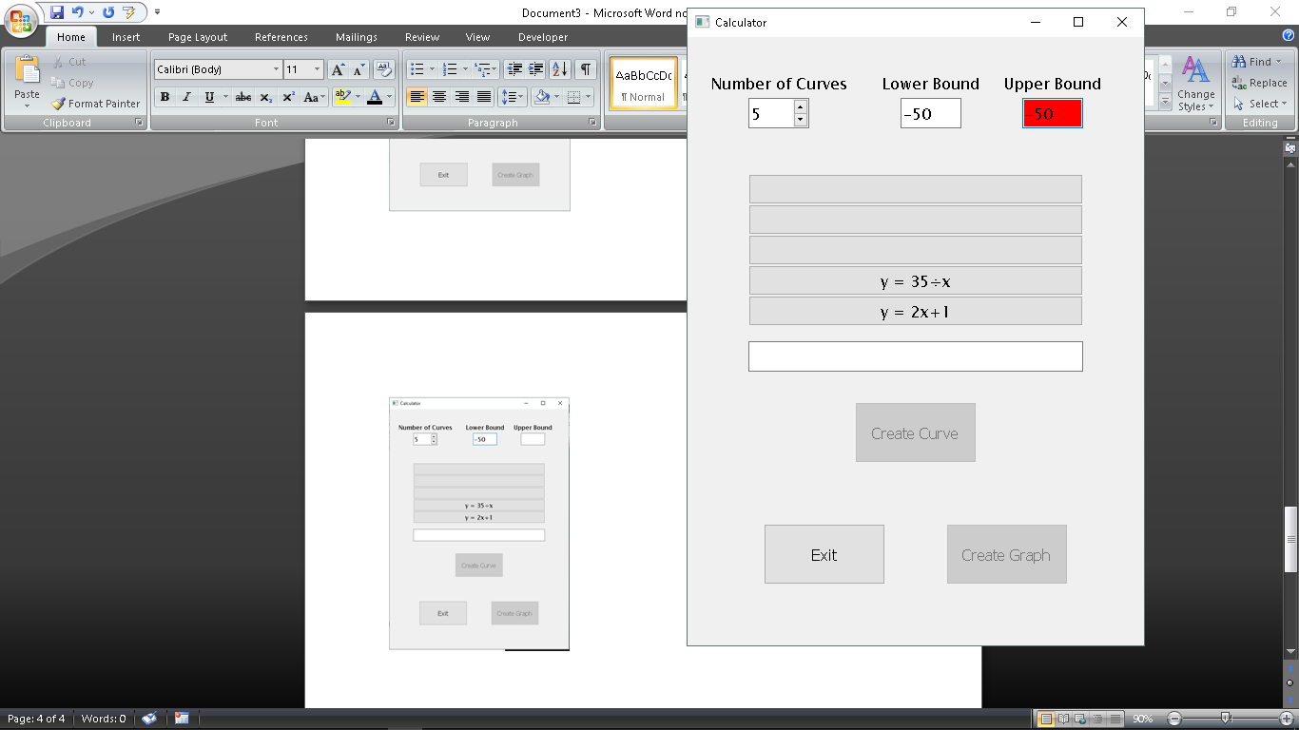

As can be seen, the upper and lower bounds cannot be equal.

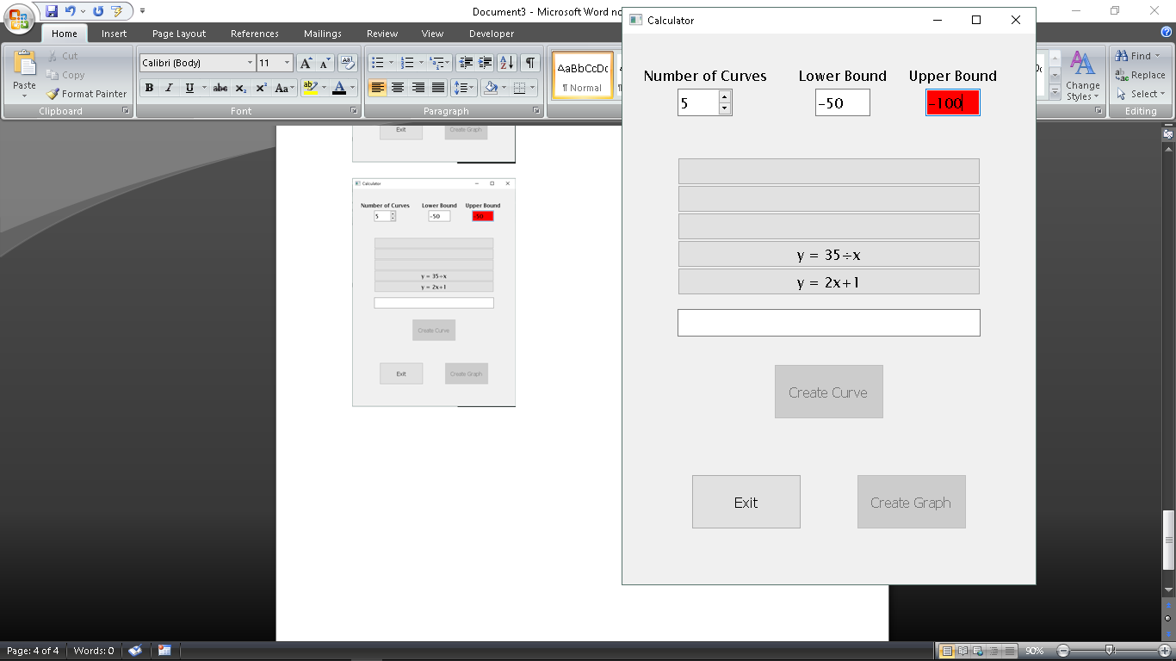

The upper bound cannot be less than the lower bound.

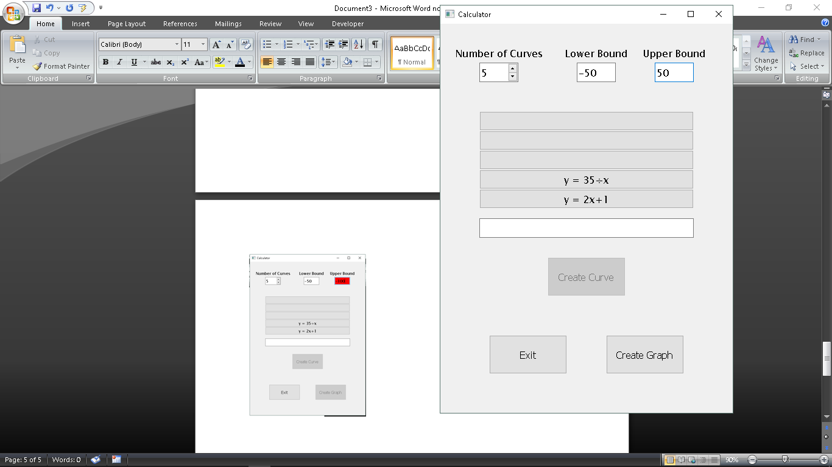

A reasonable upper bound and lower bound allows a graph to be created. As can be also seen, not all slots must be filled to create a graph.

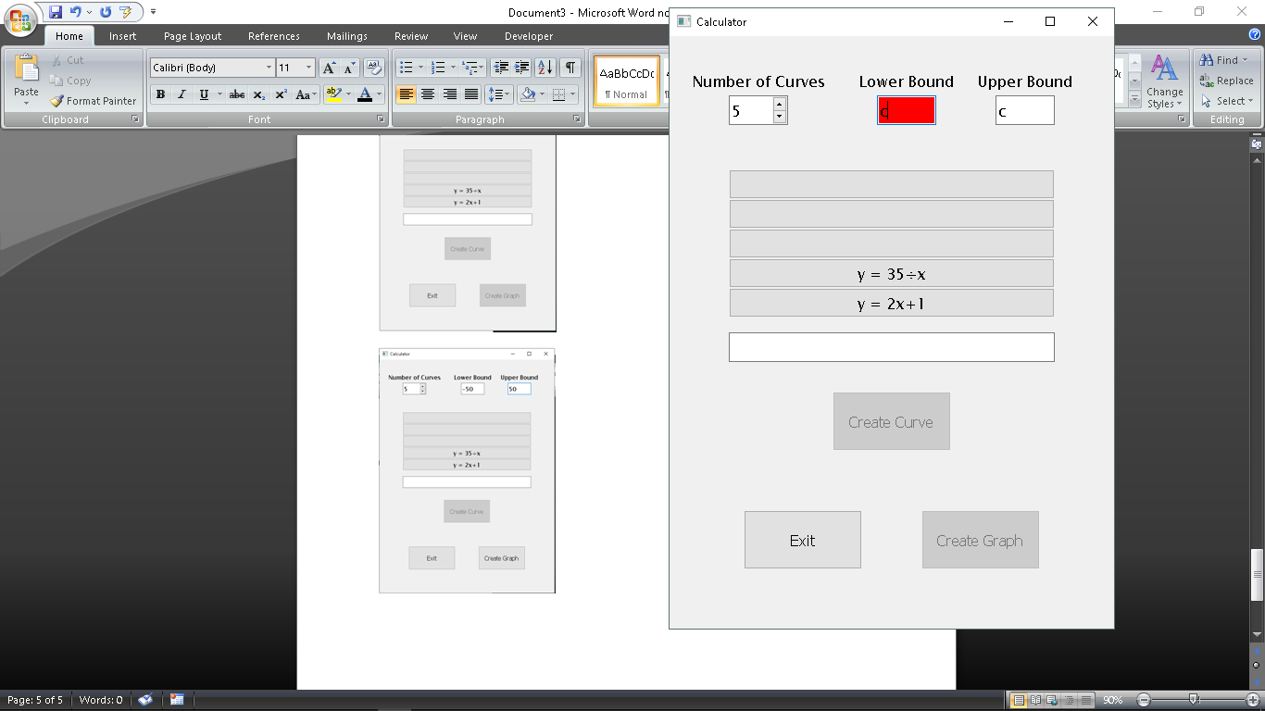

As can be seen, algebraic constants can be used in the creation of bounds.

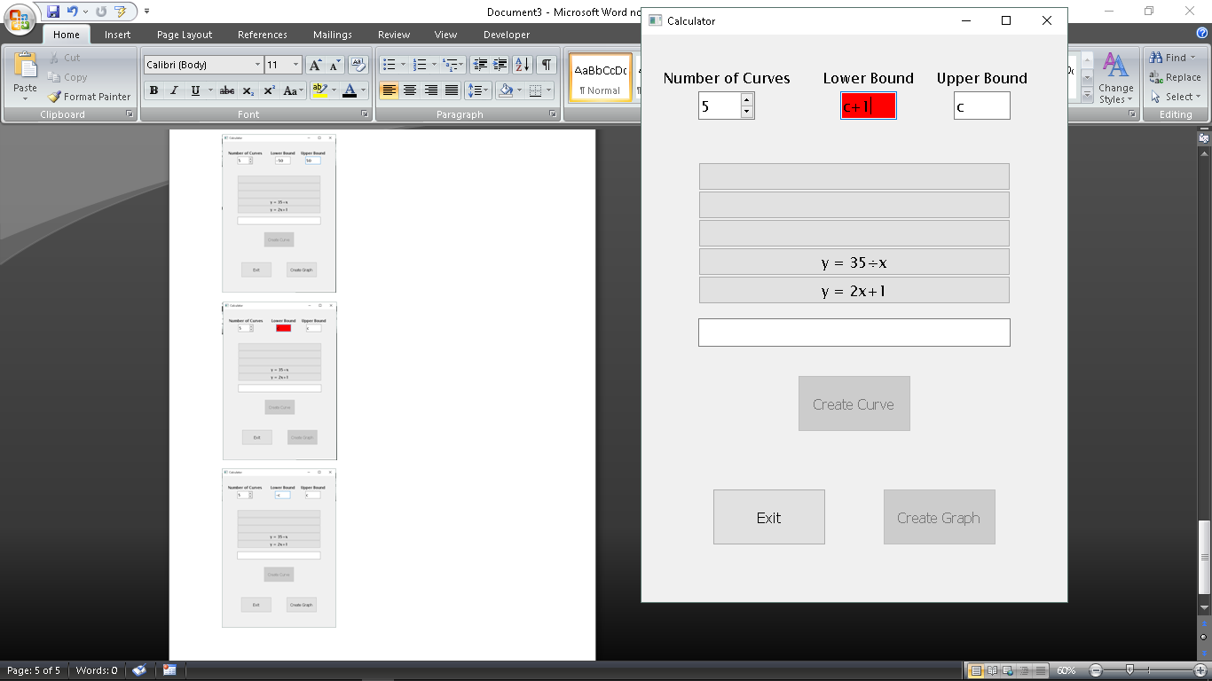

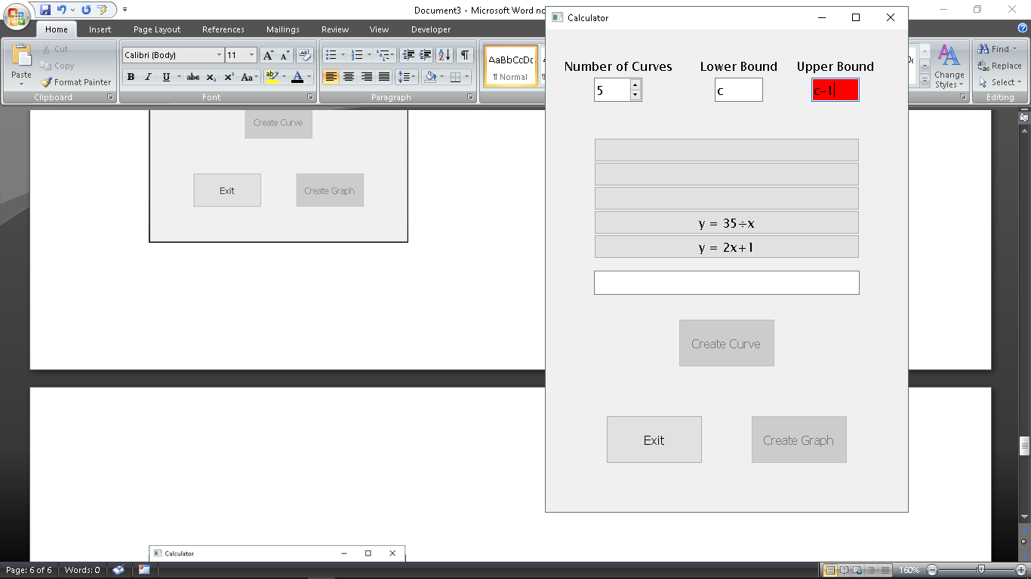

Bounds can be entered algebraically, utilising the standard operations.

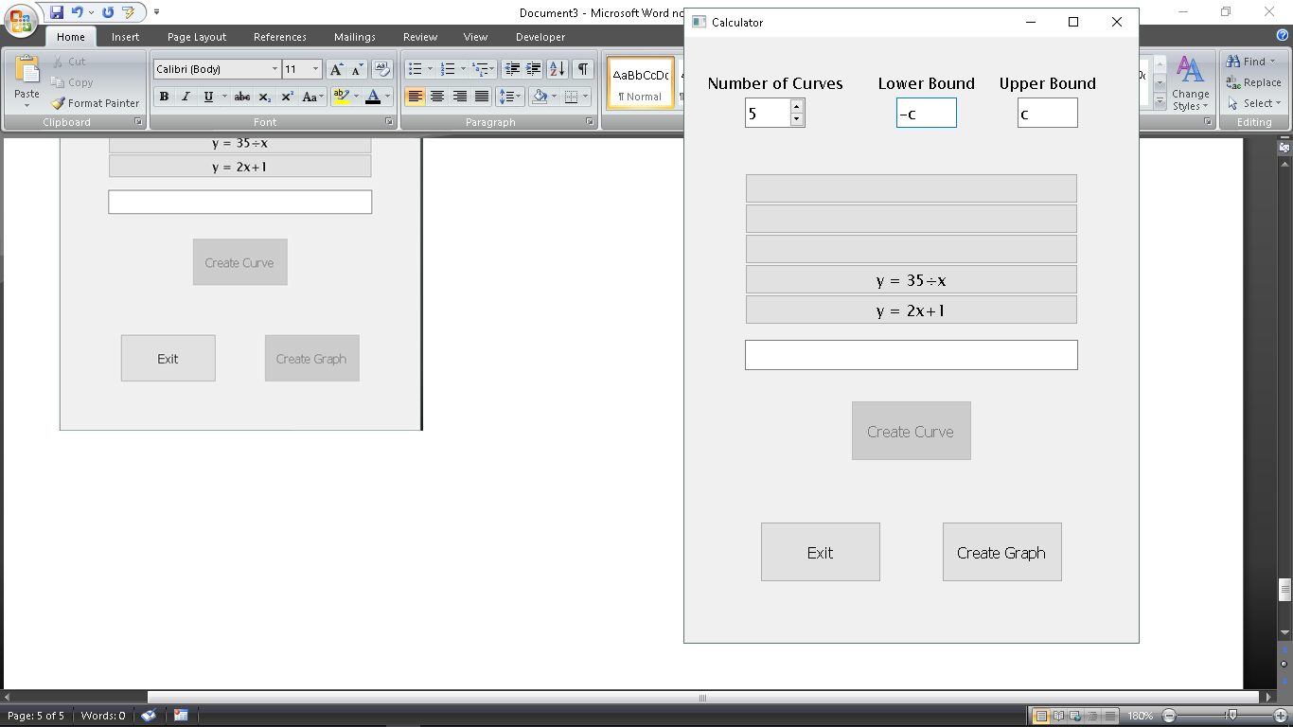

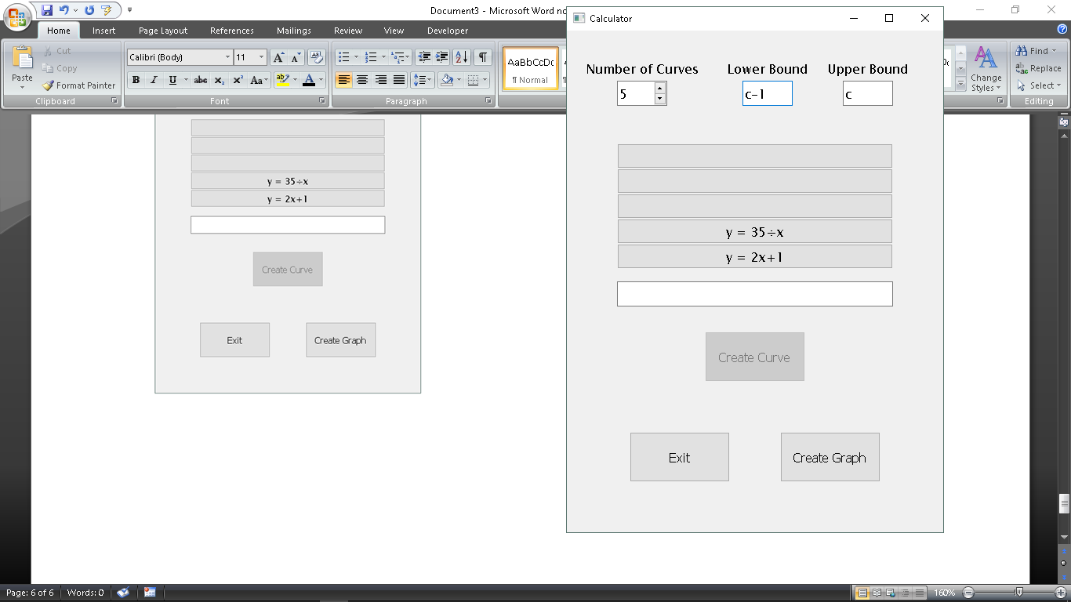

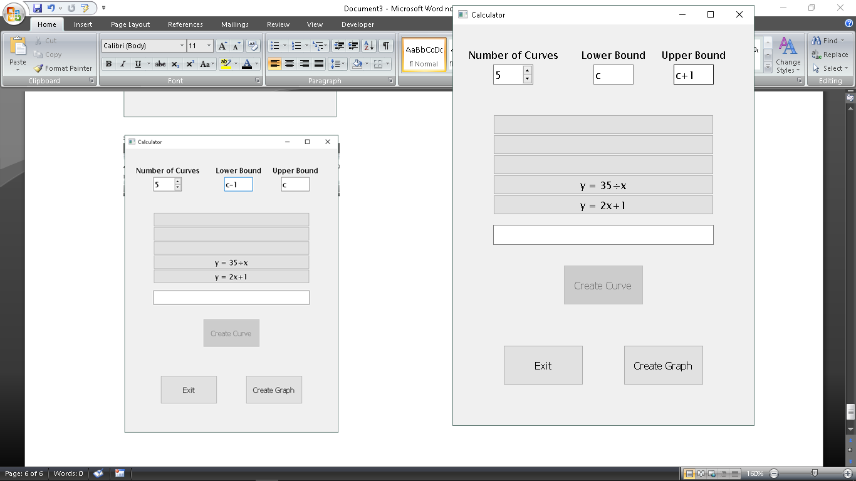

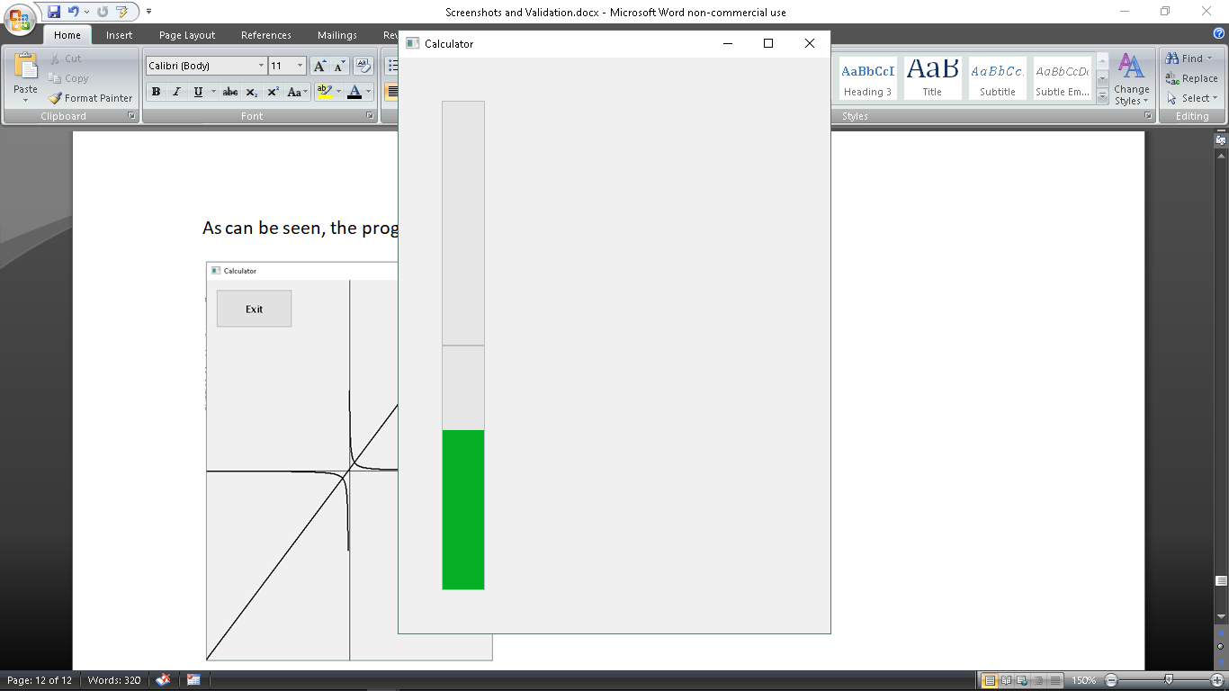

As can be seen, the progress bar is filled vertically. In addition, there are a number of bars that correspond with the number of entered equations, not with the number of slots. However there is no other

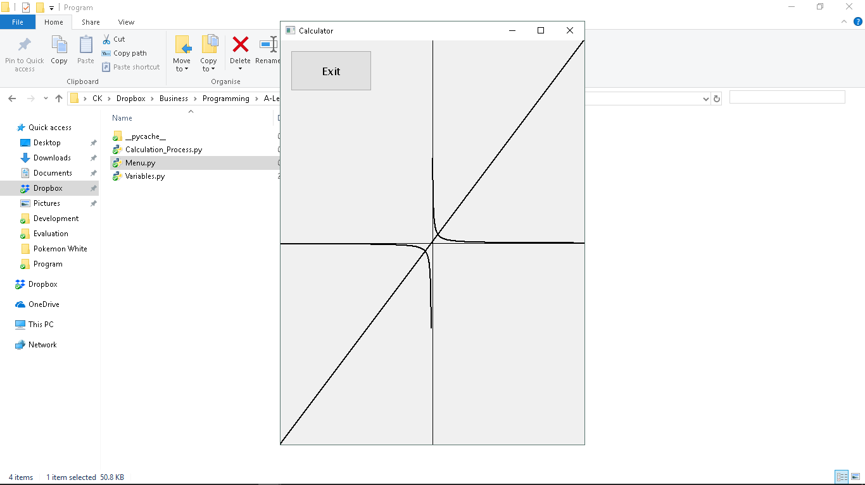

As can be seen, the graph shows both curves, correctly drawn. In addition, the ‘Exit’ button is placed at the top left of the window.

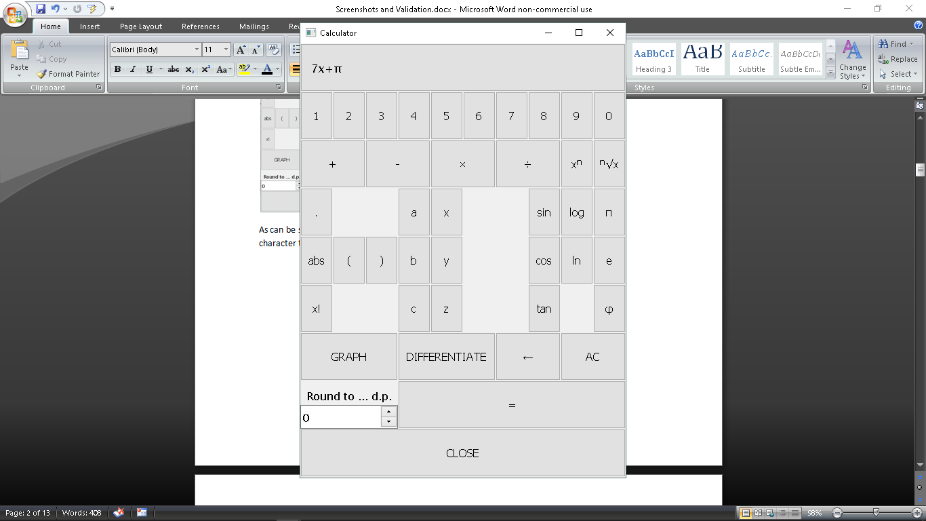

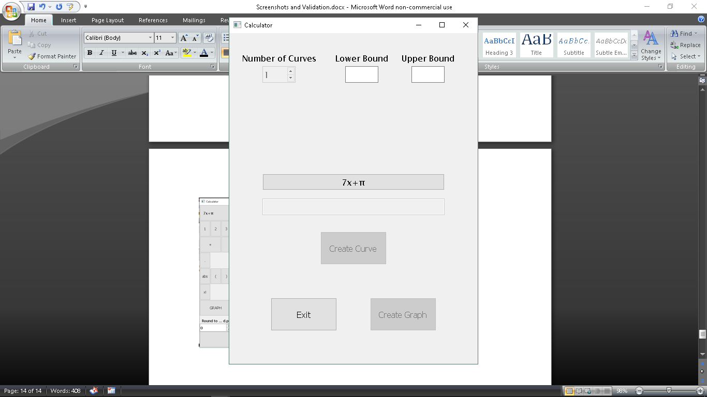

As can be seen, when creating a graph through the calculator, there may only be one curve that can be graphed.